Guidance on helping to refine our national mapping of key river/stream types
Chris Mainstone, Natural England
January 2023
Purpose
This guidance explains how to help with local ground-truthing of predictive national maps for key river/stream types of importance in biodiversity action and reporting. This will help these river/stream types receive the level of attention they deserve. Note that separate guidance exists for chalk streams/rivers.
How does it work?
- Provisional predictions have been made of the distribution of different river/stream types – you can provide local feedback on their accuracy in reflecting the natural character of rivers and streams at a local level via the data portal on the FBA Discovering priority habitats website.
- To reflect the UK-level nature of the predictive mapping work, the data portal accepts contributions from anywhere in the UK (the website and data portal are generally only designed to operate in England).
- The data portal stores all information provided on local natural character and makes it available for refining model predictions.
- Local information provided can be viewed on the Data display facility here (for English locations) and on the map facility on Cartographer (for all UK locations).
- The revised predictive maps will be made available as an open data set and built into biodiversity planning, assessment and reporting processes
1. Background
Domestic UK and international legislation lists a range of broad river and stream types that require a particular conservation focus. Distribution maps of these types are required by Natural England and parallel statutory nature conservation bodies in other parts of the UK (known as the Statutory Nature Conservation Bodies, SNCBs) in order to enable tailored assessments of (and reporting on) their status, help structure monitoring and data collection programmes, target conservation action and audit progress with conservation action.
2. Which types needs to be considered?
Domestically, the definition of ‘priority river habitat’ under the UK biodiversity framework (and enshrined in domestic legislation in each part of the UK) includes the following river/stream types:
- Habitats Directive Annex I habitat H3260 - ‘watercourses of plain to montane levels with Ranunculion and Batrachion vegetation’;
- headwater streams;
- chalk rivers (including small chalk streams);
- active shingle rivers.
The IUCN Red List initiative provides another important mechanism for understanding the status of different river and stream types. The global river typology used by the IUCN has been interpreted at European-level as part of a European Red List of Habitats, using the EUNIS classification. It comprises the following types.
- C2.1a Base-poor spring and spring brook
- C2.1b Calcareous spring and spring brook
- C2.2a Permanent non-tidal, fast, turbulent watercourse of montane to alpine regions with mosses
- C2.2b Permanent non-tidal, fast, turbulent watercourse of plains and montane regions with Ranunculus spp
- C2.3 Permanent non-tidal, smooth-flowing watercourse
- C2.4 Tidal river, upstream from the estuary
- C2.5a Temperate temporary running watercourse

The Red List typology is intended to be a holistic framework to which any river or stream section can be allocated. The river/stream types included in the UK definition of priority river habitat do not constitute a holistic typology; they overlap with each other and have a complicated relationship with the European Red List typology.
Other types not represented on either list but need to be considered include bedrock channels and rivers/streams with differing levels of alkalinity (water hardness).
3. Progress with predicting type distributions
Predicted UK distributions of some of these river and stream types have been generated by the UK SNCBs (Natural England, NatureScot, Natural Resources Wales and DAERA Northern Ireland), and work is on-going to refine these and add predictions of other types. A report on progress to date is provided here.
Predicted types are currently held on a 50-metre spatial grid that follows the pattern of the river and stream network. The grid can be overlain on any digital river network to show the predicted habitat character of each river/stream section.
4. How you can help with ground-truthing predictions
We need local information on how well the predicted distributions of certain river/stream types reflect reality on the ground. You can tell us about the typological character of any river section or stream, and we will collate the information we receive and use it to evaluate the robustness of predictions and refine model algorithms to reflect local knowledge as far as possible. To help develop better predictive models we are particularly interested in locations where predictions poorly reflect natural character.

5. How do I know a river/stream type when I see it?
Before giving a brief explanation of different river/stream types that we need assistance with, it is important to bear the following points in mind.
- Nationally predicted distribution maps are a coarse representation of local reality. Their primary purpose is to understand the habitat resource at national scale, not to steer local assessment or management (which should avoid the use of typologies as far as possible).
- The habitat character of a river or stream section can vary considerably over short distances. We are generally trying to reflect the broad character of a river reach or stream rather than capture the small-scale variation in habitat character, although it is also useful to know about the variation in habitat character within a river reach or stream.
- We are attempting to map the natural habitat character of the river and stream system by reference to river/stream types. Artificial modifications to the physical channel, as well as alterations to flow and sediment regimes and water chemistry can obscure natural habitat character. It is important to try and see through the artificial modifications and judge which river/stream type(s) would manifest under unmodified conditions.
Table 1 sets all relevant river/stream types within a framework that characterises the ecological relationships between types. We mainly need local ground-truthing of the types in the left-hand column, broad descriptions of which are given in the central column. A photo-guide to these types can be found in Appendix A.
6. Using the appropriate form on the FBA priority habitat data portal
Go to the Mapping river/stream types page of the data portal. If you are not already registered for the Priority Habitats workspace on Cartographer (for instance for adding information on naturalness or restoration priorities) then fill out the contact form to register for an account.
Once registered, click the button ‘Log in to input data’ - this will take you to a sign-in page (on Cartographer). Enter the email address and password associated with your account. If the web site prompts you to “Select a Workspace”, click on the option ‘Priority habitats workspace’. Then click “Add a Survey” and choose the form for ‘Mapping river/stream types – other types’.
The map embedded in the form allows you to zoom into locations that you know. Clicking on the map snaps you to the nearest river/stream section, highlighting it and automatically filling in basic details. The river/stream types predicted to occur in the section are shown as coloured, segmented circles – the map legend provides detailed explanation.

Table 1. Integrated portrayal of river and stream types relevant to biodiversity strategy. Red – types included in the Red List typology. Green – Types included in the UK definition of priority river habitat.
Key hydraulic/geomorphic types | Ecological description | Other types*
High energy with boulders/cobbles (C2.2a) | Conducive to bryophyte dominance. Fish community dominated by salmonids, bullheads, stoneloach. Varied invertebrate fauna adapted to hostile hydraulic conditions. | Headwater streams (<2.5km from source, derived from the digital river network):  - Base-poor spring/spring brook (C2.1a)  - Calcareous spring/spring book (C2.1b)  - Other  Temporary streams and rivers (C2.5a) – generally headwater streams but can be small rivers.  H3260 (largely C2.2b)  Chalk rivers (largely a chalk subset of H3260)  Low, moderate and high alkalinity rivers streams (derived from modelled alkalinity data)
Bedrock channel (not in Red List typology) | Little in-channel vegetation except attached (often long-lived) algae. Fish community typically dominated by salmonids. Limited invertebrate fauna adapted to hostile hydraulic conditions.
Active shingle sections - High-moderate energy, very dynamic gravel substrate | Little in-channel vegetation except attached (generally short-lived) algae. Fish community dominated by salmonids. Varied invertebrate fauna adapted to hostile hydraulic conditions and substrate disturbance.
Moderate energy dominated by largely stable gravels (C2.2b) | Conducive to dominance by rheophilic (fastwater-loving) submerged higher plants, rheophilic cyprinids such as dace and chub, and rheophilic invertebrates (stoneflies, mayflies).
Low energy dominated by sand and silt (C2.3) | Conducive to limnophilic (stillwater-loving) plants, fish and invertebrates
Tidally influenced river and stream sections (C2.4) | Naturally supports a mixture of freshwater and estuarine species and allowing the life cycles of many estuarine/coastal fish species (e.g. bass, mullet, smelt, flounder) to be fulfilled.
*No simple relationship with key hydraulic/geomorphic types
The form then allows you to indicate which river/stream types you judge are naturally associated with the river/stream section you have selected, as well as indicate the overall typological character. This is not an exact science – just select the types that best fit the natural character of the river/stream section, using the photo-guide in Appendix A as an aid. River and streams exhibit continuous longitudinal variation and there will be many instances where it’s unclear which type or types best fit a given location – just choose the best fit and use the confidence assessment on the form to indicate how good the fit is.
There is a facility for you to upload photos of the site, to provide a visual picture of habitat character.
There is also a free-form text box to which you can add notes about your judgements.
7. Providing more general feedback about provisional distribution maps
You may have more general thoughts about the predicted distributions that cannot be captured by the data entry form on the data portal. In particular, you may have suggestions for refining the national data analysis so that it better captures particular types. General comments of this nature should be sent to chris.mainstone@naturalengland.org.uk.
8. Displaying local contributions to our knowledge of river/stream types
Any information provided via the form on the Data Portal that relates to locations in England will be visible on the ‘Display data’ tab of the FBA Discovering priority habitats website. Go to the ‘Mapping river/stream types’ option to see the type distributions and local ground-truthing information. Information provided that relates to other parts of the UK can be viewed on the map facility of Cartographer.

Appendix A – Photo-guide to river/stream types
Red List C2.2a - High energy, conducive to domination by aquatic mosses
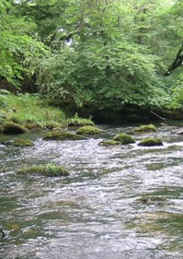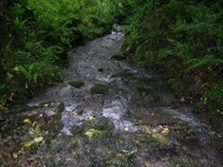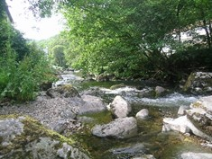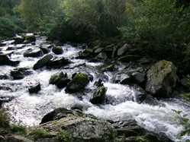
Bed-rock channels
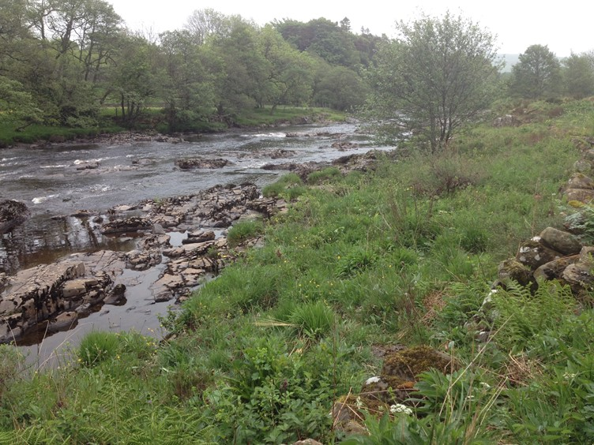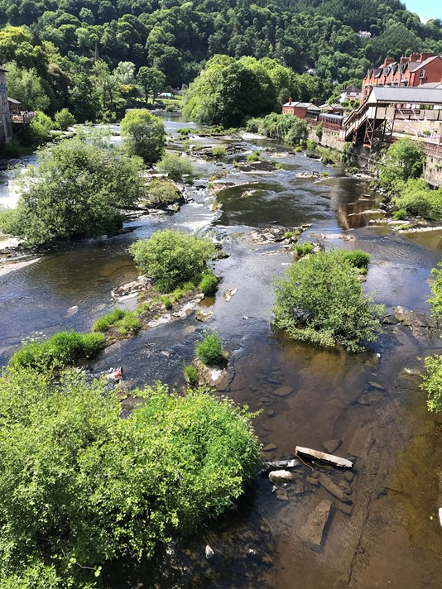

Active shingle sections
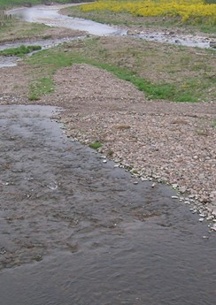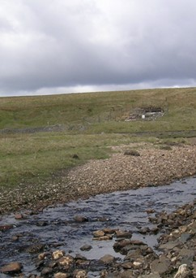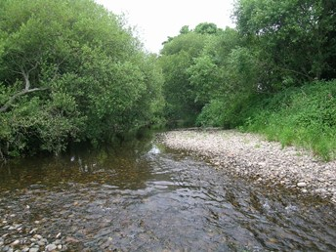

Red List C2.2b - Stable gravel/cobble bed, conducive to dominance by rheophilic (fastwater-loving) submerged macrophytes
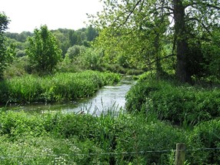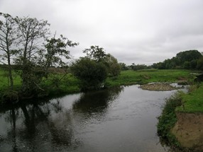
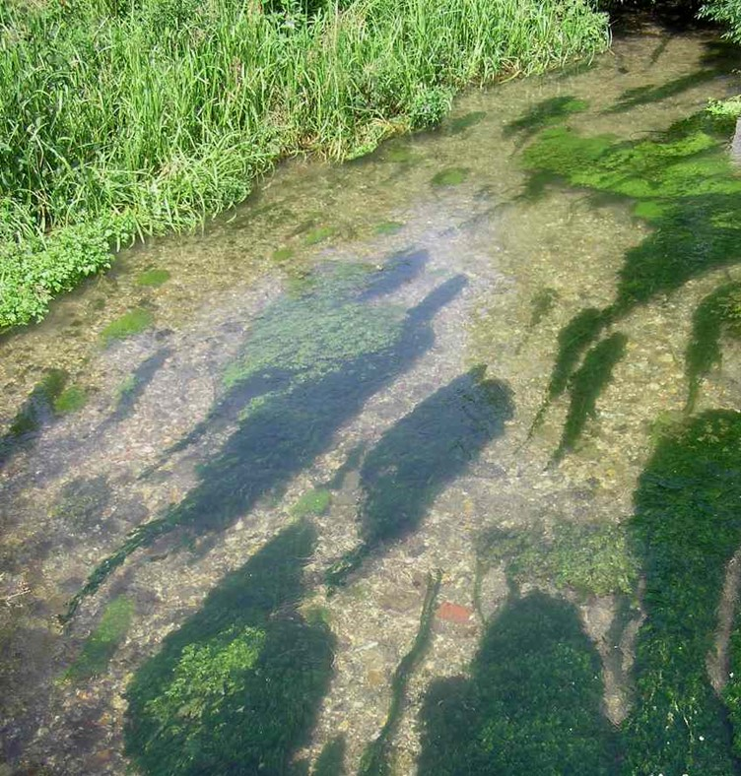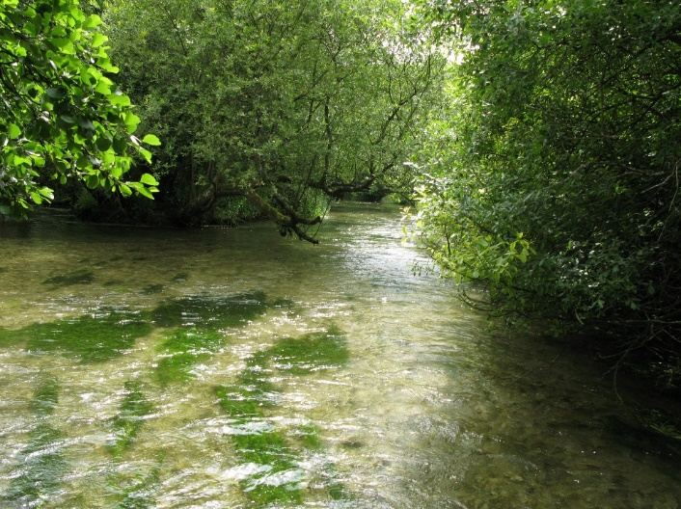

Red List C2.3 - Slow-flowing, dominated by silts and sands and conducive to dominance by limnophilic (stillwater-loving) submerged macrophytes (e.g. Potamogetons)
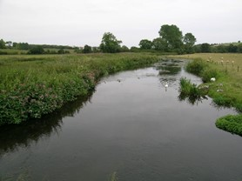

Red List C2.4 - Tidally influenced sections
