Report on progress with developing the Defra 25 Year Environment Plan indicator B6 – naturalness of water and wetland habitats
Chris Mainstone¹, Cedric Laize², Francois Edwards², Ruth Hall¹ and Richard Jeffries³
¹ Natural England, ² Centre for Ecology and Hydrology, ³ Environment Agency
Consultation version, July 2021
Summary
This report documents collaborative work on the B6 indicator undertaken over the past year by CEH, Natural England and the Environment Agency, as part of wider Defra-funded work on the indicator framework for the 25 Year Environment Plan. The work builds on previous collaboration between Natural England and CEH, assisted by the Environment Agency, to develop a new framework for assessing the naturalness of the freshwater habitat resource for the purposes of reporting against Defra biodiversity objectives.
A good provisional version of the rivers and streams component of the indicator has now been generated, containing national datasets on a range of attributes. This has involved a considerable amount of data processing and some bespoke modelling, and the development of a visualisation approach (wheel diagrams) that is capable of portraying complex and hierarchical data outputs in a compact way. It has not been possible to make further progress on the lakes and ponds components but this is planned for this year (2021/22), depending on availability of funds. Integration of B6 work with development of the headline biodiversity indicator D1 (extent, quality and connectivity of habitats) is on-going and requires careful attention.
Successful operationalisation of the B6 indicator is dependent on the development of new strategic monitoring programmes currently under development within the Defra Family, as well other Environment Agency data sources (such as groundwater and flood risk modelling) and citizen science programmes. Optimising these data sources and the B6 data framework is a critical activity to generate an indicator that is sufficiently sensitive to change in the water and wetland habitat resource resulting from changes in pressures including restoration action.
By Spring 2022, subject to securing funds, it is anticipated that the rivers and streams component of B6 will be ready for ‘concept’ testing by Defra as part of wider reporting on the 25 Year Environment Plan indicator framework. By this time the data framework and data visualisation arrangements for lakes and ponds components should also be ready for informal consultation with experts and key partners. Development work on the wetlands component is dependent on progress with the D1 indicator. Further consideration is needed of how best to progress the transitional and coastal water component of B6.
Acknowledgements
Thanks are due to those who have helped with the sourcing and use of data for this current phase of work: Carlos Garciadeleaniz and Josh Jones at Swansea University in relation to the AMBER dataset; Mark Whiteman, Matthew Ramscar, Judith Bennett at the Environment Agency and Dave Ottewell at Natural England for assistance with sourcing and using groundwater data. The work has also benefited from datasets and analyses gathered under previous work documented in Natural England Research Report JP016, which contains further acknowledgements of assistance (including Environment Agency hydrology and Water Resources staff). We are grateful to Karen Mullin at Defra who has supported the work and helped with securing continuing funding.
Contents
- Introduction 3
- Scope of the work and links to the D1 indicator 4
- Progress with the rivers and streams component 5
  - Preamble 5
  - Hydrological naturalness 7
  - Physical naturalness 12
  - Chemical naturalness (water quality) 19
  - Biological naturalness 20
  - Monitoring and evaluation requirements 22
- Portraying data 23
- Scoping future work on lakes and ponds 26
  - Lakes 26
  - Ponds 30
- Future work on the B6 indicator as a whole 31
- Concluding remarks 32
References 33
Appendices
Appendix 1 - Classification rules used for assigning naturalness 34
classes to rivers and streams
Appendix 2 - Detailed explanation of the modelling of stream power 35
Appendix 3 - Further detail on river and stream attributes generated 37
from the standard River Habitat Survey method

1. Introduction
Indicator B6 sits within Defra’s 25 Year Environment Plan (25YEP) indicator framework and is a progression of technical proposals for monitoring and assessing freshwater habitats in relation to priority habitat objectives, as laid out in Natural England Report JP016 (Mainstone et al. 2018). The indicator is based on evaluating levels of naturalness (or natural ecosystem function), providing not only a sound ecological framework for restoring water and wetland habitats but also a common language for maximising synergies between biodiversity and water decision-making and restoring natural capital (including for climate change adaptation and mitigation, natural flood management, and resilience and quality of water resources). This language is equally applicable to open freshwater (rivers, streams, lakes and ponds), wetland, estuaries and coastal waters.
The biodiversity rationale for using naturalness/natural function as the basis for conserving freshwater and wetland habitats is explained in the ‘freshwater and wetland habitats narrative’ (NE Report NERR064 - Mainstone et al. 2016), and summarised in a series of biodiversity fact sheets generated to inform delivery under the Water Framework Directive (WFD) Catchment-Based Approach (CaBA) initiative. Increased recognition of the importance of protecting and restoring natural ecosystem function to all habitats and species (terrestrial, wetland, aquatic), to different degrees in different places depending on circumstance, is driving an ecological shift in biodiversity decision-making (Report NERR071 - Natural England 2018). This has recently been reinforced by the development of a new ‘habitats and ecosystems narrative’ (Natural England 2020), which outlines the shift in mindset needed and the measures required to embed it in operational decision-making processes for biodiversity.
Indicator B6 is positioned to contribute to this strategic shift and help build an ecological bridge between biodiversity and water decision-making, contributing to and influencing the content and structuring of 25 YEP headline biodiversity indicator D1 (extent, quality and connectivity of habitats). Developed in the right way, these indicators can provide the framework and supporting datasets needed to develop future biodiversity targets that have ambitions for restoring more natural ecosystem function embedded within them. This provides the basis for building ecosystem restoration more squarely into biodiversity planning and associated operational processes, as envisaged by on-going international discussions on the post-2020 global biodiversity framework under the Convention on Biological Diversity.
Naturalness is a broad concept with many different facets. It can be thought of as the consideration of all of the ecosystem structures and functions that are involved in making natural ecosystems what they are, with functions shaping structures in complex, interactive and dynamic ways. There is no simple way of measuring it directly – many different attributes can provide different windows in on it but do not provide an overall assessment in themselves. Any indicator of naturalness therefore has to be compound in nature, covering hydrological, physical, chemical and biological components and drawing on a range of evidence strands to provide a complete picture. This makes its development more complicated than many indicators, and its interpretation more involved.
It is worth emphasising that it is generally simpler to evaluate the level of artificial modification to ecosystems than to characterise what a natural ecosystem looks (or should look) like in any given place and evaluate deviations from that. This is because indicators of modification often have an in-built (or at least more easily quantified) reference condition of ‘no modification’, which equates to ‘natural’ in the context of that indicator. This is important in the selection of attributes and monitoring regimes, and highlights the strong relationships between pragmatic assessment of naturalness/natural function and the assessment of human pressures.
2. Scope of the work and links to the D1 indicator
The spatial rationale for the B6 indicator is to evaluate the entire national resource of water and wetland habitats, using a mixture of data sources and representative sampling where needed. Whilst the B6 indicator is intended to cover open freshwater and wetland habitats and transitional (estuaries) and coastal (TRAC) waters, progress across all of these habitats within the Defra/CEH MOA has not been equal. Available resources under the MOA and the make-up of the CEH project team on B6 necessitated a focus on certain elements (particularly rivers and streams, lakes and ponds).
Partway through 2020, discussions with those involved in the development of the D1 indicator looked at overlaps and synergies between D1 and B6. The D1 indicator aims to evaluate the entire national resource of all land-based (non-marine) habitats, including open freshwater and wetland habitats. TRAC waters are considered out of scope for D1 because they are dealt with under 25 YEP marine indicators. It was agreed that B6 should provide the open freshwater habitat component of D1, whilst development of the wetland habitat component of B6 should be led by D1 development. It was further agreed that there needed to be strong collaboration between the development of D1 and B6 to ensure a complementary framework is developed for the two indicators, explicitly incorporating characterisation of natural function and making best use of available water-related datasets. This complementary framework, and the definition of attributes within it, is being taken forward through collaboration between the Natural England leads for the two indicators.
Within open freshwater habitats, recent work on B6 has focused on rivers and streams, because data exist to generate a working model of this component of the indicator. Progress with lakes and ponds has not been possible with the resources available. There is a lack of data for some candidate attributes (particularly for lakes and ponds), and future progress is dependent on appropriate data being generated through the Natural Capital and Ecosystem Assessment (NCEA) monitoring programme that is currently in a pilot stage and is dependent on funding. Work on lakes and ponds under the Defra/CEH MOA has been restricted to scoping out next steps in development (subject to funding being secured), on the assumption that sufficient data could, dependent on funding, eventually be generated by the NCEA monitoring programme to enable the full range of components to be assessed.

3. Progress with the rivers and streams component
3.1 Preamble
Work has focused on trimming down and refining the original list of attributes developed in Report JP016 (Mainstone et al. 2018), as well as simplifying the spatial framework originally proposed for aggregating data. A summary of the attributes now being included in the rivers and streams component is provided in Table 1. Data on all attributes have been resolved into a common spatial framework based on WFD surface waterbodies, originally used in work reviewing the river SSSI series (Mainstone et al 2014a). Each WFD waterbody is divided up into two components: 1) headwater streams and 2) larger river sections. This framework provides a reasonable level of spatial resolution and allows evaluation of the naturalness of the headwater stream resource to be separated from the main river network in a way that generates greater focus on this critical component of the habitat resource. The partitioning of the headwater stream component separates out small-scale catchment areas of <10km² within each waterbody. This is broadly synonymous with the UK priority river habitat definition of headwater streams (within 2.5 km from source at 1:50,000 scale map resolution), and links in with the WFD classification of small river waterbodies.
All data are resolved into a 5-class classification of naturalness, with Class 1 being very high and Class 5 being very low. Classification rules for all attributes used in this report are provided in Appendix 1. Some attributes are based on full spatial coverage of the habitat resource (albeit with data limitations) whilst others are based on representative sampling of the resource. This mixed data model needs to be borne in mind when considering filtering the underlying data to portray the naturalness of different spatial components of the resource (for instance, within a region of England, or within a catchment, or within a particular river type).
Some attributes are portrayed largely as they would appear in the final B6 indicator, whilst for other attributes we have had to use provisional data pending the establishment of data handling processes to secure data that are fit-for-purpose (in terms of providing an updateable dataset that can track changes in naturalness in a coherent and consistent way). Since a range of attributes rely on the generation of representative survey data within the headwater stream resource and the main river network, this needs to be taken into account in the development of national monitoring programmes currently being designed within the Defra family.
Whilst each attribute is considered separately and data aggregation across attributes is purely statistical, it is important to remember that there are complex interactions between different impacts on naturalness that have to be taken into account in the way that more natural function is restored to habitats and ecosystems. A classic example of this is the interplay between hydrological functioning of the floodplain and the water quality of floodwaters, where we seek river/stream-floodplain reconnection but need to avoid inundating restored floodplain wetland mosaics with heavily artificially enriched floodwater. These interactions are not something we intend to address directly in the portrayal of the B6 indicator, but they are important in local decision-making linked to improving the level of natural function in the habitat resource.
Table 1. Attributes being used for the rivers and streams component of B6.
Naturalness component | Attributes | Comments | Read-across to Indicator D1 pillars of natural function¹
Hydrological | Flow regime – deviations from naturalised flows | Larger rivers only- from EA Water Resources Management System | Pillar 1 - Hydrological
 | Groundwater inputs | Separate assessments of headwater streams and larger rivers – from EA groundwater monitoring and modelling
 | Floodplain function | Separate assessment of headwater streams and larger rivers - % of floodplain flooding naturally based on flood defence assets. Calculated from EA GIS floodplain layers
Physical | In-channel structures | Separate assessments of headwater streams and rivers. Uses AMBER and EA data, potentially updated via CaBA citizen science initiative | Pillar 3 - Soil and sediment processes
 | Stream power | Separate assessments of headwater streams and larger rivers. New CEH modelling of the whole river/stream network.
 | Habitat Modification Score | Separate assessments of headwater streams and larger rivers using representative sampling of each. Based on River Habitat Survey data.
 | Flow habitat mosaic
 | Riparian trees |  | Pillar 4 – Vegetation controls
 | In-channel woody material
 | Riparian vegetation complexity
 | FBA physical naturalness assessment | Separate assessment of headwater streams and larger rivers. From representative sub-sampling of naturalness assessments on the FBA priority habitats data portal. | Pillars 3 &4
Chemical (water quality) | Ammonia | Rivers - from WFD reporting database.  Streams – requires additional representative sampling programme of the headwater stream resource | Pillar 2 - Chemical (Nutrient) status
 | Dissolved oxygen
 | Phosphorus
 | Nitrogen
 | pH
 | Macroinvertebrates
 | Phytobenthos
Biological | Native species assemblage - similarity index comparing observed and reference invertebrate assemblages | Separate assessment of headwater streams and larger rivers. Requires EA data of high taxonomic resolution, including representative sampling of headwater streams | Pillar 5 - Species composition
 | Non-native species - combined score weighted by species impact | Requires species records collated via the National Biodiversity Network or the Biological Records Centre
¹. Development of the D1 indicator is using the five pillars of natural function described in Report NERR071 (Natural England 2018). These are largely synonymous with the four components of naturalness used here for freshwater habitats but include an explicit fifth component on vegetation controls, which under B6 is currently included in the physical component of naturalness.

3.2 Hydrological naturalness
3.2.1 Flow regime – deviations from naturalised flow
A natural flow regime is critical to the shaping of the river/stream/floodplain ecosystem and sustaining its characteristic biological communities. The data for this attribute (Figure 1) are currently taken from the naturalness assessment undertaken within the review of the English river SSSI series (Mainstone et al. 2014a), and the classification rules are as used in those assessments (Appendix 1). Natural England Report JP016 (Mainstone et al. 2018) proposed on-going assessment of this attribute by regular extracts from the Environment Agency’s Water Resources GIS, based on the framework of Assessment points across England. Whilst this does not give a detailed spatial picture of hydrological modifications to flow regime within waterbodies, it does provide a broad portrayal of naturalness levels that is consistent with the indicative nature of B6. It does not however provide a picture of the naturalness of flow regime within headwater streams so does not contribute to that component of the B6 indicator.
Discussions with the Environment Agency during the production of Report JP016 (Natural England 2018) provided an outline for the data exchanges needed for regular updates to the assessment of this attribute, but a specific data handling protocol to populate B6 has not yet been established.
3.2.2 Groundwater inputs
This attribute is critical to the evaluation of hydrological naturalness in the headwater stream resource, because direct monitoring and evaluation of flows in England is focused on larger watercourses further downstream (see Section 3.2.1). Discussions between Natural England and the Environment Agency have identified the type of data required as well as the broad nature of data portrayal. Model outputs are required in order to provide a level of spatial resolution consistent with the spatial framework being used for the rivers/streams component of B6.
The data shown in Figure 2 are from model outputs from groundwater models used by the Environment Agency in East Anglia. Data are only shown for headwater streams – work is on-going to generate a parallel output for larger rivers. Similar groundwater models exist for many other major aquifers but not all. Ways of filling in spatial gaps in coverage are currently being discussed to make the attribute as representative as possible of the naturalness of groundwater inputs. These discussions have emphasised the critical importance of investing in groundwater modelling as a means of better characterising impacts on temporary and perennial streams and wetlands in headwater catchments across England.

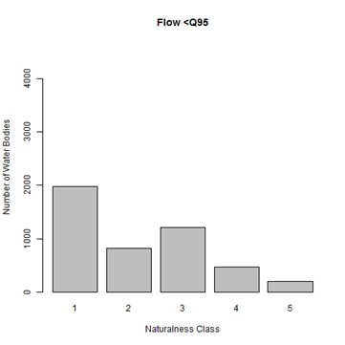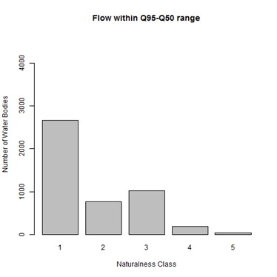
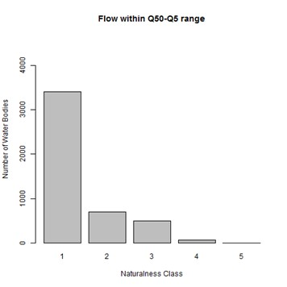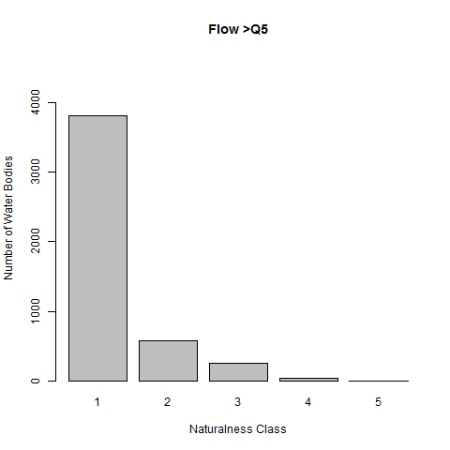
Figure 1. Naturalness of larger rivers according to different components of the flow regime ((Naturalness class 1 = very high, Class 5 = very low). Classes are based on levels of deviation (positive or negative) from natural flows.
To generate Figure 2, modelled scenario of groundwater-to-surface (GW-to-SW) water flows were compared, aggregating modelled data from a 200-metre spatial grid into the headwater stream component of each WFD waterbody. The scenario for recent actual groundwater abstraction (and artificial recharge) volumes was compared with modelled naturalised GW-to-SW flows under a typical low-flow scenario (Q90, i.e. the flow that is exceeded for 90% of the year). This was chosen as the most appropriate scenario because the groundwater model simulates the combined effect of abstraction across the whole year on the groundwater levels in the aquifer, and the greatest aggregated impact on the stream flow regime is at low flows.
The data provides good characterisation of the effects of general modifications to groundwater tables. This attribute cannot provide a full picture of hydrological impact on headwater stream flow regimes because it only deals with groundwater abstraction, and within that only abstractions that require a licence. Very small groundwater abstractions and surface water abstractions and diversions may affect individual streams or stream systems, but this is not possible to characterise through this sort of modelling. Citizen science surveying of the naturalness of individual streams (the hydrological component) can provide indications of these other impacts and may be a useful addition to the set of attributes for B6 currently included in Table 1.

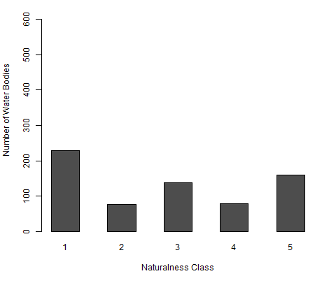
Figure 2. Naturalness of headwater stream flow regimes according to abstraction impacts on groundwater contributions. (Naturalness class 1 – very high, Class 5 = very low). Classes are based on levels of deviation (positive or negative) from natural flows (see Appendix 1 for class boundaries).
3.2.3 Floodplain function
The ability of the floodplain of rivers and streams to flood naturally is critical to the functioning of the river/stream ecosystem and the development/restoration of natural floodplain wetland mosaics (in tandem with restoration of groundwater inflows via valleyside spring zones and floodplain upwellings). Artificial modifications to floodplain flooding regimes are most obviously generated by formal flood defence infrastructure but also by informal flood defences and channel oversizing (widening, deepening) and straightening associated with floodplain drainage. The effect of some of these modifications on floodplain function are easier to evaluate than others – it has only been possible to include the effect of major Environment Agency flood defence assets in this attribute. Non-major flood defences and channel modifications are characterised under physical naturalness (Section 3.3), but only in terms of their impact on channel naturalness not their impact on natural flooding regime.
The current portrayal of the attribute (Figure 3) is derived from the Environment Agency Flood Map GIS layer of the natural floodplain modelled with and without the effect of major flood defence assets. The natural floodplain is provided by layer ‘Areas of land at risk of flooding’ (‘nat_floodzone3_v201208’), which has a 1-in-100 year flood return period ignoring the presence of EA flood defence assets. The modelled effect of flood defence assets is provided by layer ‘Areas that benefit from flood defences’ (‘nat_areasbenefit_v201208’). Results are expressed as the percentage area of the natural floodplain that is protected against flooding (i.e. not allowed to flood naturally), calculated by dividing the area that benefits from flood defences by the area of the natural 1-in-100 year floodplain. Values are calculated for each WFD surface water body (catchment), divided up into headwater streams and larger rivers as for other attributes. WFD waterbodies with no natural floodplain (e.g. incised valleys and gorges) have been excluded to focus attention on modifiable conditions. Class boundaries have been assigned that allow reasonable discrimination of the variation in naturalness observed (see Appendix 1).
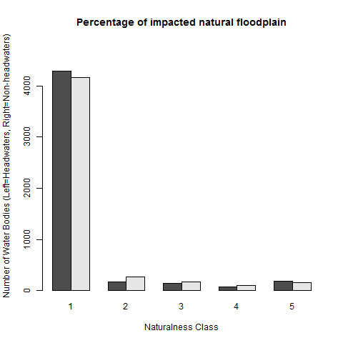
Figure 3. Proportion of the natural floodplain that is allowed to flood naturally according to the distribution of EA flood defence assets (Naturalness Class 1 – very high, Class 5 = very low). Black columns are headwater streams and grey columns are larger rivers. See Appendix 1 for class boundaries.
There is a very strong skew in the distribution of the data because of the very high number of zero values (i.e. floodplain without artificial flooding constraints from major assets).These figures will be a substantial under-estimate of the total impact on natural flooding of floodplains because of the many relevant physical modifications to rivers and streams that are not included in the evaluation. Under-estimates are likely to be worse in the small floodplains of the headwater stream resource where there are no major flood defence assets but considerable drainage and associated channel over-sizing.
It is worthwhile exploring how a more holistic picture can be achieved to help drive river and floodplain restoration in the many instances where impacts are not generated (or at least not solely generated) by major flood defence assets. This would require an England-wide or at least representative evaluation of channel oversizing and the distribution of non-major and informal flood defences (e.g. accumulated dredgings of gravels on the bankside). The extent of these impacts on river and stream channels will be indicated by attributes falling under the physical component of B6 (see Section 3.3), but this cannot be translated into spatial impacts on the floodplain without more sophisticated modelling.
A further issue with the current analysis is the ecological relevance of the flood return period used in defining the natural floodplain. A period of 1-in-100 years is typically used for flood defence purposes as a pragmatic delineation of areas at significant (socio-economic) flood risk. In ecological terms, land that is naturally only flooded (on average) once every 100 years is not intimately linked to the river ecosystem compared to land that naturally floods at higher frequencies. The use of a range of flood return frequencies in B6, as a family of attributes similar to the flow attributes used in Section 3.2.1 (Figure 1), would provide a more ecologically relevant picture of the impact on natural flooding regimes. The spatial scale of impact on areas of natural floodplain with short flood-return periods (for example, 1-in-5 years) is ecologically very important and proportionately will be much greater than the impact on the natural 1-in-100 year floodplain. This is discussed in more detail in Report JP016 (Mainstone et al. 2018).
It is important to consider the extent to which datasets of this nature are updated and how sensitive they would be to change in levels of modification to the habitat resource. The frequency and spatial extent of updates to the GIS layers used in Figure 3 need to be clarified. These layers will also only be sensitive to changes in the magnitude and extent of major flood defence assets, which will often be less relevant to floodplain restoration than other flood defence measures since they are focused on protecting urban areas where there is no scope for restoration.
It would also be valuable to indicate the proportion of flooded area that is under natural or semi-natural vegetation, since the direct biodiversity value of natural flooding is eliminated if the flooded land is under intensive land use. This can be added to the attribute relatively simply through GIS overlay.

3.3 Physical naturalness
3.3.1 Artificial in-channel structures
In-channel structures (artificial weirs and impoundments) interfere with the free movement of water, coarse and fine sediments, and living and dead organisms (including large dead woody material), generating a wide range of impacts on natural and dynamic in-channel and riparian habitat mosaics and associated characteristic biological communities. Removing in-channel structures as far as this is achievable is a critical action for restoring river and stream ecosystems.
For this attribute data have been extracted from a broader inventory generated by the cross-European AMBER project (Figure 4), which includes data collated by the Environment Agency. The locations and hydraulic head (drop on water height) have been resolved into the WFD waterbody framework to generate aggregate values for: 1) the total number of recorded structures and 2) the total hydraulic head of those structures. The data have been classified according to rules originally used in the naturalness assessment described in Mainstone et al. (2014a) and in the mapping of priority river habitat (Mainstone et al. 2014b, 2015). The class boundaries used are shown in Appendix 1.
Given the known prevalence of in-channel structures in the river and stream network it is perhaps surprising that so many waterbodies are falling into the highest naturalness category. This may be a product of adopting a relatively detailed level of spatial resolution for the B6 data framework, where the total number of structures is divided between some 4.500 waterbodies and then between headwater stream and larger river components within each waterbody. In the context of headwater streams it will also be because of under-recording of structures.
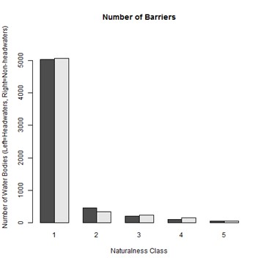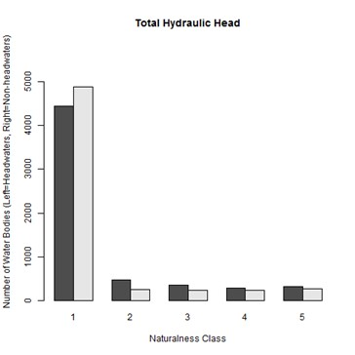
Figure 4. The naturalness of rivers and streams according to the number and size of artificial in-channel structures (Naturalness class 1 – very high, Class 5 = very low). Black columns are headwater streams and grey columns are larger rivers. Class boundaries are shown in Appendix 2.
It would be useful to investigate other potential classification rules for in-channel structures. An attribute with broader spatial scope than individual waterbodies is worth considering but would not fit so easily into the general spatial framework for aggregation that has been adopted for the rivers and streams component of B6. One possibility is to use the average length of free-running river upstream from the sea, which in addition to providing a broader habitat connectivity perspective would be particularly relevant for anadromous and catadromous fish species. However, this would under-represent the picture upstream of the most downstream in-channel structure on the river system, unless other attributes were also used (such as those already shown in Figure 4). An estimate of impounded channel length could be generated by using a combination of channel slope (from GIS datasets) and barrier height, which could be expressed as a percentage of total waterbody length.
In terms of on-going data collection for this attribute, procedures need to be developed in collaboration with relevant citizen science initiatives and the Environment Agency. Whilst there is a citizen science facility to update the AMBER dataset directly, there are also plans to record in-channel structures within the WFD CaBA initiative, linked to possible updating of the Environment Agency’s dataset.
Since there is likely to be a significant level of under-recording of structures on the headwater stream resource, on-going survey and monitoring of structures is likely to generate significant increases in recorded structures. This has the potential to spuriously affect the B6 indicator by showing an apparent reduction in naturalness. Dynamic adjustment to the baseline set for this attribute may be required.
3.3.2 Stream power
Stream power is a measure of the ability of a stream or river to do ‘geomorphological work’, i.e. shape its own physical form by eroding and depositing sediments and other materials (such as dead wood), thereby creating dynamic habitat mosaics for characteristic biological assemblages. Stream power is affected by a range of human modifications and may be artificially lowered or increased depending on circumstance. Artificially reduced stream power results in reduced ability for self-recovery, whilst artificially enhanced stream power can result in unnaturally unstable channels that fundamentally alter river behaviour (e.g. crossing a system threshold to become far more energetic and dynamic), or generating artificially extreme erosion and sedimentation issues or flooding regimes.
Natural stream power values vary widely across the river and stream network, depending on the nature of the catchment and the specific characteristics of a particular river or stream section. The attribute generated for B6 compares an estimate of observed stream power with an estimate of putative natural stream power. Generating stream power estimates for this exercise requires a good deal of intensive GIS-based modelling at high spatial resolution, followed by data aggregation to WFD waterbody level (divided into headwater stream and larger river components). The ratios generated are shown in Figure 5. Naturalness class boundaries (shown in Appendix 1) were chosen to provide sufficient sensitivity at the high end of the naturalness spectrum whilst providing a reasonable spread of the habitat resource across the other classes.
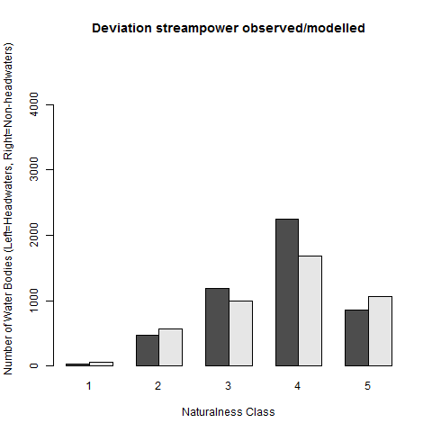
Figure 5. The naturalness of rivers and streams according to modelled modifications to stream power (Naturalness class 1 – very high, Class 5 = very low). Black columns are headwater streams and grey columns are larger rivers. See Appendix 1 for class boundary values.
In terms of the analytical process, a UK-wide data layer for reference (predicted natural) stream power had already been generated by CEH for a UK-level project modelling river/stream types for biodiversity reporting purposes (Mainstone et al. in Draft). A parallel and compatible dataset on observed stream power has been generated specifically for B6, based on proof-of-concept modelling by the national Geomorphology team of the Environment Agency. Both data layers were modelled on a 50-metre grid, to allow a ratio of observed:reference stream power to be generate (expressed as deviations from reference value, either negative or positive). The ratio values from individual 50-metre grid cells were then aggregated into the waterbody framework used in B6.
Standard methods were used for calculating both total stream power and specific stream power for existing and reference river channels, the calculation differing in the handling of channel width. Total stream power was calculated as the kinetic energy of the flow during a 1-in-2 year flood (which approximates to bank full); as flow, or river gradient increases, the power increases. The total power was divided by existing or modelled ‘natural’ channel width to give specific stream power – the power per metre width of the channel which matches the actual energy applied to the channel boundary fairly closely. It is this energy that drives natural geomorphic processes such as erosion and deposition. Further details of the calculations are provided in Appendix 2.
The reference (i.e. predicted natural) stream power values carry a higher degree of uncertainty than the existing values. There are three main sources of uncertainty. Firstly, the reference values are based on an empirical equation of natural channel width, which was derived from a limited number of semi-natural sites. All of the sites were considered un-impacted when the equation was created in 2001, but more recent research (e.g. Cluer and Thorne, 2012) has shown that even the least modified single-thread channel with a floodplain is a product of centuries of anthropogenically-accelerated fine sediment deposition derived from catchment land use change. A second source of uncertainty is that the natural flow was sourced from a national model; as with the channel width, the underlying model is in part the result of anthropogenic influences, though these were removed as far as possible. Finally, channel slope data were derived from a GIS rivers layer which reflects the current configuration of river/stream planform in England, so is influenced by channelisation activities that have reduced river/stream length and artificially increased channel slope. Notwithstanding these sources of uncertainty, the predicted values provided an efficient and physically-based first step towards an estimate of deviation from natural across the river/stream resource as a whole. Given the sources of uncertainty, the predicted natural stream power values should be treated with appropriate caution if used for local targeting of restoration action.
With the algorithms used, differences between observed and reference stream power values rely heavily on estimates of reference and observed channel width, with artificial narrowing of the channel generating artificially high stream power and hence artificially high erosive forces. Refinements to the algorithms are possible to generate a more holistic characterisation of impacts on stream power. For instance, use of a historical base layer of rivers and streams (prior to the substantial channelisation of the post-World War II era), if available in digital form, would provide a better indication of natural channel slope with which to compare observed slope., and assessment of a range of natural channel types and widths may provide greater insight into the natural habitat resource, and how far from it current systems are.
Ultimately, there are limitations to what can be achieved through a national modelling exercise and the purpose of the B6 indicator needs to be borne in mind. A more sophisticated local approach is needed to evaluate impacts on a specific river/stream section and to plan restoration measures. This spatial layer generated for B6 might be of use in targeting particular local areas for more detailed attention, but its main purpose is to provide an overall picture of naturalness/modification at national scale that can help generate momentum for habitat restoration.
3.3.3 Attributes relating to River Habitat Survey
The River Habitat Survey method collects a wide range of geomorphological and vegetation data within 500-metre survey reaches. Periodic representative national surveys have been undertaken by the Environment Agency which provide the basis of a representative assessment of the habitat resource. Data on Habitat Modification Score, flow habitat mosaic, riparian trees, in-channel woody material and vegetation complexity are displayed in Figure 6. Further explanation of the allocation of waterbodies to naturalness classes is given in Appendix 3. For this exercise, data have been used from RHS ‘baseline’ surveys (representative national surveys in 1995/96 and 2007/08) and Countryside Survey monitoring sites in 2000 and 2007). Note that RHS baseline data from 1994 were excluded because 1994 constituted a trial of the method and inconsistencies occurred in recording habitat features.
Habitat Modification Score (HMS) - This is a standard compound RHS metric derived from a range of indicators of physical modification of channel and banks assessed as part of the standard River Habitat Survey method. Modifications within the metric include re-sectioning, reinforcement, poaching, weirs, culverts and bridges. HMS provides a useful overall impression of the level of physical modification, which complements attributes below that evaluate the impact of those modifications. For this exercise data were pre-processed into Habitat Modification Class, which is a standard RHS output derived from HMS. The five HMC classes were adopted as the 5 classes of naturalness.
Flow Habitat Mosaic (FHM) – This is a compound attribute used in Report JP016 (Mainstone et al. 2018), formed from the ‘flow sub-score’ of the Habitat Quality Assessment score generated by River Habitat Survey. It indicates the complexity of in-channel habitat mosaics created by small-scale variations in current velocity - high values of the attribute are generally associated with natural riverine processes, where the interaction between the natural flow regime, the natural channel and tree roots and fallen wood generate complex and dynamic in-channel mosaics. However, this is not always the case and care needs to be taken in interpreting data - high FHM values associated with low Habitat Modification Scores are a good indication that habitat diversity is a result of natural processes and natural ecosystem function.
Riparian trees – Riparian trees are a critical element of natural river/stream function and their absence is a major impact on naturalness. This attribute was developed for Report JP016 (Mainstone et al. 2018) and relates to the density of trees and their natural interaction with water and sediment processes in the channel. Data are derived from the sweep-up stage of the River Habitat Survey method. The relationship between riparian tree cover and habitat condition is not simple. Patchy tree cover (such as would be provided naturally by tree fall and the action of herbivorous animals) provides the best opportunities to cater for the full characteristic community of a river or stream. Whilst higher levels of tree cover than this are desirable to combat rising water temperatures caused by climate change, they may or may not be desirable from a conservation perspective: in woodland higher cover would be expected and desirable. For this reasons, naturalness class boundaries are set so that it is possible to achieve the highest naturalness class for this attribute on the basis of >33% tree cover (this is the highest cover level used in RHS). This means that the attribute considers a wide range of tree cover values as being consistent with natural function and of high conservation value.
In-channel woody material – This attribute was developed for Report JP016 (Mainstone et al. 2018) and provides a semi-quantitative assessment of the amount of woody material in the channel. Woody material in river channels varies in size from small twigs to whole trunks. It falls from bankside trees and lodges in the channel or is carried by flow until it gets jammed. Woody material in the channel provides shelter and food for an array of fauna, generates differential scour of the bed and banks and consequent variation in water depth, bed substrates and bank profiles, and provides critical drought refugia. Higher levels of woody material are associated with higher levels of natural function. Care in data interpretation needs to be taken in high altitude areas where trees are naturally absent, but only the very highest altitude areas of England are naturally treeless. Data for this attribute are derived from the sweep-up component of the standard River Habitat Survey method.
Riparian vegetation complexity – This attribute was developed for Report JP016 (Mainstone et al. 2018). Variation in vegetation complexity, from trees and scrub to short and long herbaceous swards, is important for supporting complete characteristic biological assemblages of rivers and streams (in-channel and riparian) and is a product of low levels of artificial vegetation controls (low livestock grazing densities, lack of intensive mowing/cutting). High values of this attribute are generally associated with high levels of natural function, although lower scores may be generated in woodland with dense canopy cover which may not be a product of low naturalness.
3.3.4 FBA physical naturalness assessment
This attribute relates to a citizen science initiative developed by Natural England in collaboration with the Freshwater Biological Association (FBA) and a range of partners and stakeholders. The initiative is intended to improve our understanding of the naturalness of the river and stream (as well as the lake) habitat resource in England, particularly headwater streams (and small lakes) where there is the greatest knowledge gap. It feeds into future refinements of the priority river habitat map as well as the assessment of the river and stream habitat resource via the B6 indicator. Details of the method (and the parallel lakes method) can be found on the FBA priority habitat website, where there is also a citizen science portal for adding data. Whilst it allows assessment of all four naturalness components of B6, the physical habitat assessment is likely to be most useful to B6 because it is the easiest to undertake and is likely to provide the most reliable results.
This is a new method and data portal facility and the future level of uptake within the citizen science community is not yet clear. It is not possible to present data in the context of B6 at present because there are too few data points, but available data are displayed on the FBA priority habitat website. Hopefully the system will be well-used and will provide a good data set for the B6 indicator to draw on in future. If used there will need to be a protocol for representative sub-sampling of the dataset to avoid bias.

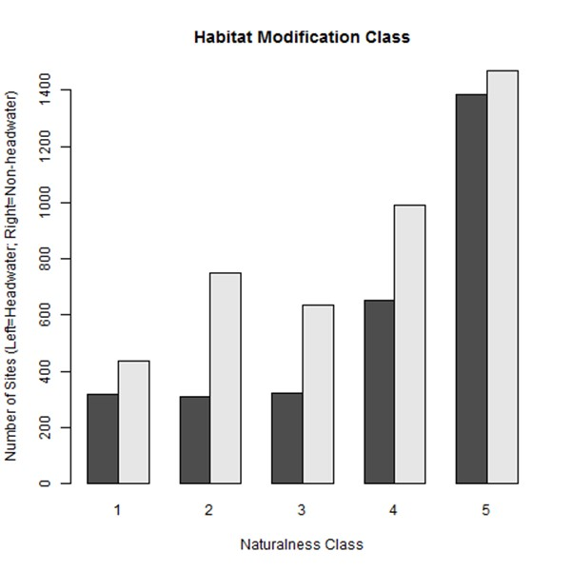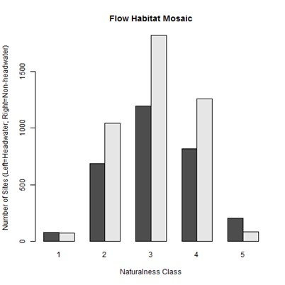
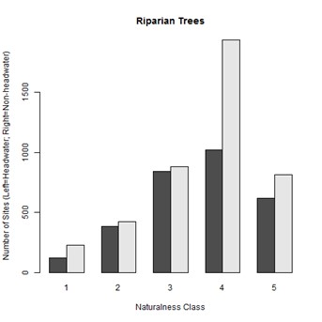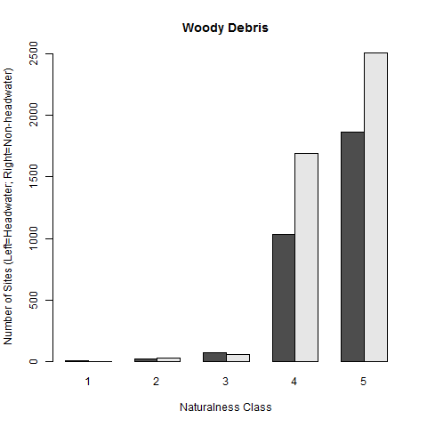
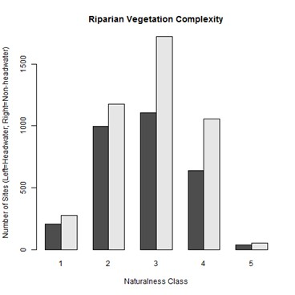
C
Woody meerialFigure 6. Naturalness of WFD waterbodies according to RHS-derived attributes (Class 1 = very high, Class 5 = very low). Black columns are headwater streams and grey columns are larger rivers.

3.4 Chemical naturalness (water quality)
To provide a broad indicator of water quality and help generate consistency of evaluation across Defra 25 YEP indicators we have taken data on key metrics in the Environment Agency’s WFD reporting database. This has necessitated adopting the UK WFD standards supporting high, good, moderate, poor and bad ecological status as naturalness classes for the chemical component. These standards are not listed in Appendix 1 because the precise standard values applicable vary according to variations in natural environmental conditions – for phosphorus, standards are site-specific.
The WFD reporting database only provides an evaluation of whole WFD waterbodies, which means that at present we cannot report separately on headwater streams and larger waterbodies. Current WFD monitoring is in any case heavily focused on larger rivers, so it would not be possible to provide a meaningful evaluation of the headwater stream resource. For this reason results shown in this report have been exclusively assigned to larger rivers (Figure 7). Characterisation of the headwater stream resource will not be possible until new representative monitoring of headwater streams is established, currently being considered under the NCEA monitoring pilot and subject to funding.
WFD biological metrics have been included under chemical naturalness because their structure and application is largely geared towards detecting impacts on water quality, determined by either the nature of the metric or the nature of the monitoring protocol or both. WFD reporting of ‘headline’ biological metrics is not designed to evaluate hydrological or morphological impacts (although there are supporting metrics that attempt this). They are also not designed to detect impacts on species composition or to detect direct biological impacts on that composition (e.g. non-native species, fishery management). This is explained further in the freshwater and wetland habitat narrative (NE Report NERR064 - Mainstone et al. 2016).
The spatial coverage of current WFD monitoring for different attributes varies considerably, and the targeting of WFD monitoring is broadly based on risks of failing to achieve good ecological status. This means that monitoring is not representative of the habitat resource as a whole, and is particularly lacking in headwaters. In terms of establishing on-going reporting against the B6 indicator, new monitoring programmes being developed by the Environment Agency will provide a representative picture of the status of the national habitat resource.

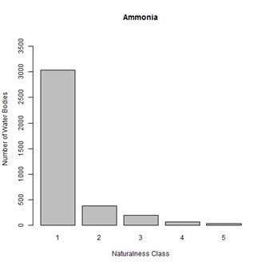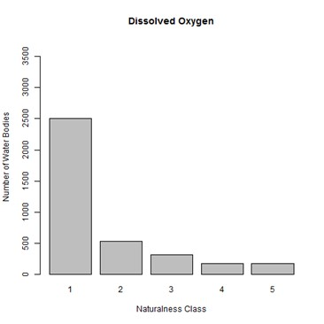
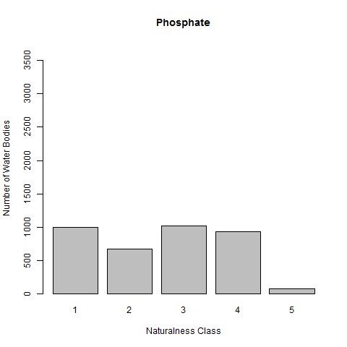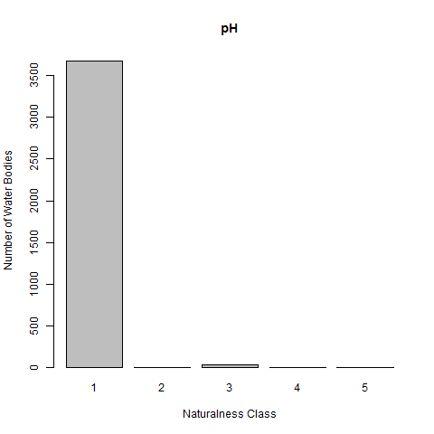
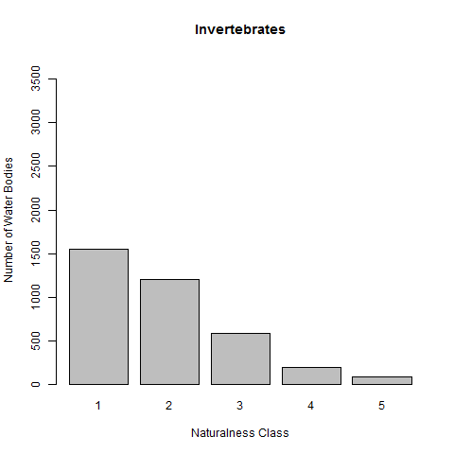
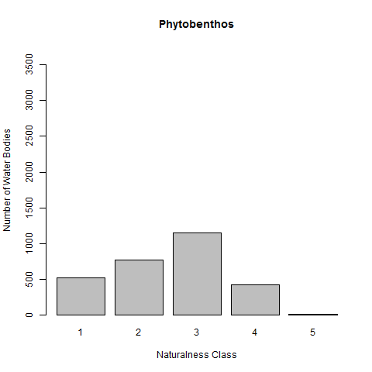
Figure 7. Chemical naturalness of larger rivers according to selected WFD chemical and biological metrics (Class 1 – very high, Class 5 = very low). Note no WFD reporting data on nitrogen were available.

3.5 Biological naturalness
3.5.1 Native species assemblage
Generally, the biological component of naturalness is focused on evaluating impacts that are not covered by the components of naturalness outlined above, such as the presence and prevalence of non-native species (see Section 3.5.2 below) and direct population control or exploitation (particularly of the native fish community). A direct assessment of the naturalness of the biological assemblage does not quite fit this conceptual model because it would integrate the effects of many different types of impact on different components of naturalness. This attribute is therefore best seen as more of a cross-check on whether other indicators of naturalness are adequately characterising impacts.
A similarity index comparing observed and reference species composition is an obvious device to use for this attribute, but it requires a good understanding of the biological community expected under unimpacted conditions. The intention is to use a macroinvertebrate attribute developed as part of Report JP016, because it can take advantage of the RIVPACS model that predicts reference macroinvertebrate communities from key environmental variables that have been selected to be unaffected by human modification. Unlike WFD reporting metrics for river macroinvertebrates, a similarity index is based on a direct comparison of observed species composition with the predicted reference species composition, rather than a comparison of metric values that are based on taxonomic composition.
To date it has not been possible to undertake the necessary analysis to show this attribute in action. It would require representative macroinvertebrate monitoring at a detailed level of taxonomic resolution (species-level for most taxa), which is becoming more achievable as Environment Agency monitoring is moving to higher levels of taxonomic penetration. Owing to the detailed protocols of WFD monitoring design it would still detect water quality impacts better than other types of impact on naturalness (physical, hydrological, direct biological).
It is envisaged that this attribute will be developed at a later date, to a point where it could be included in the B6 indicator. There are some specific issues with the characterisation of reference assemblages (particularly in headwater streams and chalkstreams) that would need to be resolved for this attribute to provide a robust evaluation of the naturalness of the macroinvertebrate assemblage.
3.5.2 Non-native species
For this working model of the rivers component, data on non-native species have been extracted from the naturalness assessment undertaken within the review of the English river SSSI series (Mainstone et al. 2014a). The dataset was generated by creating a list of non-native species of relevance to rivers and streams and resolving records (from the NBN on a 10km² grid) onto the digital rivers network before aggregating them to WFD waterbody level. Summary scores were generated by summing the number of species present, weighted by the impact category for each species as allocated by the WFD UK Technical Advisory Group.
Data can only currently be shown for whole WFD waterbodies (Figure 8). For B6 purposes the data need to be divided between headwater streams and larger rivers in each waterbody but this has yet to be done. For the moment the dataset is therefore only being used to characterise the naturalness of larger rivers. The distribution of whole WFD waterbodies across naturalness classes is skewed towards lower naturalness classes – it is likely that the separation of headwater streams from larger rivers will show higher levels of naturalness in the headwater stream resource, due to the lower accessibility of this part of the river network to the spread of non-native species.
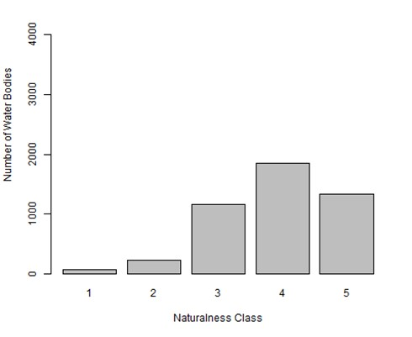
Figure 8. Naturalness of WFD waterbodies according to the presence of non-native species ((Class 1 = very high, Class 5 = very low). There is currently no separation of the data between headwater streams and larger rivers so this attribute is currently only applied to larger rivers..
A separate indicator (H2) is being developed for non-native species as part of the 25 YEP indicator framework. It would be more efficient to exploit the underlying data for that indicator if it is of appropriate coverage and spatial resolution, particularly considering the effort involved in regularly updating a separate B6 attribute.
3.6 Monitoring and evaluation requirements
The Environment Agency is now in the process of developing representative surveillance programmes for rivers and headwater streams which are well-placed to provide much of the data required for regular reporting under the rivers/streams component of the B6 indicator (summarised in Table 1). Updating some attributes will use other information sources and will require data handling procedures to be arranged and modelling work to be redone at suitable time intervals.
The spatial coverage and intensity of representative monitoring sites needs some consideration in relation to B6 and associated biodiversity reporting under the Nature Strategy. For B6 and associated reporting against biodiversity targets we would ideally be able to provide robust assessments of naturalness for key river types included in the UK priority river habitat definition: chalk rivers/streams, so- called Ranunculus rivers/streams (Habitats Directive Annex I river habitat H3260), active shingle rivers and headwater streams. This would require consideration of the spatial distribution of these different river types in the design of representative monitoring programmes, so that sites are suitably stratified to provide a reasonable picture of naturalness within each type.
Any such stratification of monitoring requires an understanding of the spatial distribution of these key river types. A robust national map of headwater streams already exists and is being used by the Environment Agency to develop the headwater monitoring programme. Work is currently underway to provide national maps of other key river types (Mainstone et al. In draft, plus refined chalk rivers mapping on www.priorityhabitats.org/) that can be used to help provide type-specific monitoring and reporting of the state of the river/stream habitat resource.
EA monitoring and associated modelling of river flows and groundwater are distinct from the EA environmental surveillance programmes discussed above. The EA Water Resources Management System is capable of providing the information needed on the river flow attribute of B6. Additional support is needed for EA groundwater monitoring and modelling to provide comprehensive data for the B6 groundwater attribute across the entire aquifer resource in England, including servicing periodic updates to B6.
4. Portraying data
Aggregating data from these different attributes and components of natural function into an understandable summary needs to be undertaken with care. The way in which this task is addressed critically dictates our ability to understand current levels of naturalness within the habitat resource as well as our ability to detect changes through time. A hierarchical framework of aggregation is needed to allow the data to be understood at different levels of summary. Wheel diagrams have been identified as the best means of achieving this, since they are capable of presenting complex data at varying levels of aggregation in one schematic. It is recognised that Defra requires a simple summary indicator for publication within the wider 25 YEP indicator framework, but wheel diagrams can lie behind this and provide an accessible interpretation of the layers of detail beneath the summary indicator.
Data portrayal needs to accommodate the following types of data in a hierarchical way:
- key habitat/ecosystem types (rivers/streams, lakes/ponds, different wetland types, estuaries and coastal waters);
- small and large waterbodies;
- key components of naturalness;
- individual attributes.
Headline reporting by Defra needs to involve high-level aggregation, which would most obviously relate to key habitat/ecosystem types. This said, it is possible to slice through the data in different ways and it might be worth considering other forms of aggregation – for instance summarising results for key components of naturalness across habitat/ecosystem types (which may be better at highlighting the limited consideration of hydromorphological impacts inherent in the reporting of WFD ecological status). Wheel diagrams can potentially be generated that provide different slices through the data.
Provisional wheel diagrams have been generated for the rivers and streams component of B6 (Figures 9 and 10), one for larger rivers and one for headwater streams to allow independent discrimination of the much-neglected headwater resource. At present a large number of attributes are blacked out in Figure 10 because there is insufficient data on headwater streams to portray them, or in some cases further work is needed to separate out a headwater assessment from the larger river assessment.
The inner circles of the wheels characterise the proportions of the national habitat resource in different naturalness classes according to individual attributes – the darker the grey shades towards the centre of the wheel, the more natural the habitat resource. The outer circles provide average class values across the habitat resource, at attribute level and at the level of key naturalness components. All attributes are weighted equally within each of the four main naturalness components, and all four naturalness components are weighted equally irrespective of the number of attributes contributed to each. An overall average naturalness value is generated from the average scores for the four main naturalness components, shown in the centre circle (bull’s eye).
In traditional reporting of habitat condition (UK Common Standards Monitoring of protected sites, WFD reporting of ecological status), data aggregation is undertaken by adopting the status of the worst-performing attribute. Whilst this approach is important for ensuring that action to achieve condition objectives addresses all components of impact, it is of less value for evaluating changes in status because no change is evident until there is positive (class) change across all attributes. Aggregation by averaging provides a vehicle for any improvements in any attribute to be reflected in the aggregated indicator.
Statistically speaking, the method of averaging in Figures 9 and 10 is somewhat ‘clunky’, in that it averages the integer class values of water bodies, firstly for each attribute across the habitat resource and then across attributes. To achieve an adequate level of resolution for indicating change, these average class values are considered to one decimal place. Although clunky, classifying data prior to averaging does allow standardisation of different types of data, even though this is at the expense of losing the continuous nature of the underlying data on each attribute. There are more statistically elegant ways of aggregating the data whilst preserving the continuous nature of the underlying data, but this can only be achieved at the expense of losing consistency/clarity of interpretation in terms of portraying levels of naturalness at the attribute level.
The precise structure of the wheel diagram is not fixed and will be subject to further consideration. There are various ways in which the data can be aggregated and limitless colour schemes. We need to find the clearest way of presenting the data without compromising portrayal of the detail.
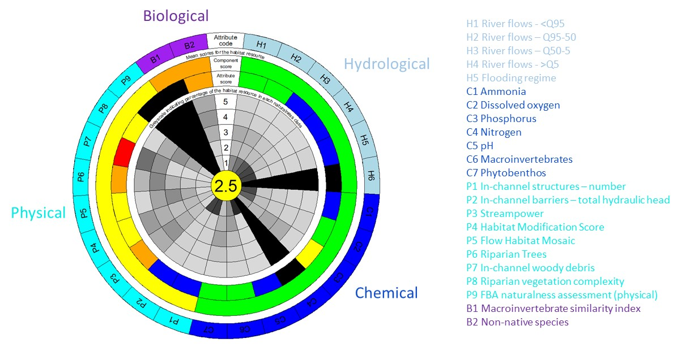
Figure 9. Wheel diagram of naturalness for larger rivers (non-headwaters). Inner 5 circles represent the proportion of the national habitat resource in each of the 5 naturalness classes (darker shades indicate higher proportion) according to each attribute used. Outer rings provide average naturalness values for each attribute and each component of naturalness (highest naturalness is blue, then green, yellow, orange, red). The outermost ring provides codes linking to the individual attributes used in the B6 indicator (coloured by naturalness component). The central circle is the average naturalness score of the habitat resource across all naturalness components. (Black segments indicate B6 attributes with no data as yet)
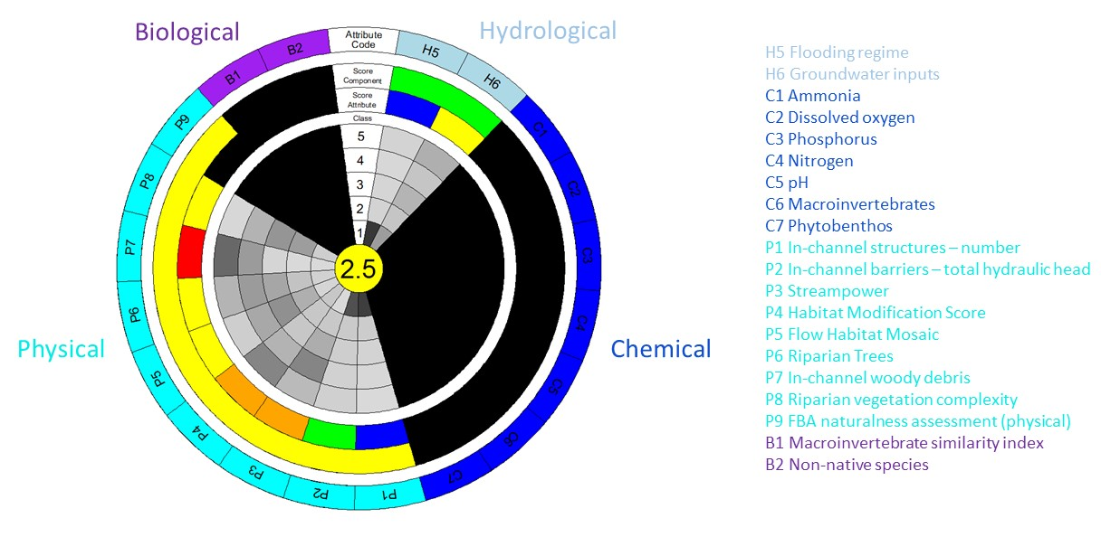
Figure 10. Wheel diagram of naturalness for headwater streams. Inner 5 circles represent the proportion of the national habitat resource in each of the 5 naturalness classes (darker shades indicate higher proportion) according to each attribute used. Outer rings provide average naturalness values for each attribute and each component of naturalness (highest naturalness is blue, then green, yellow, orange, red). The outermost ring provides codes linking to the individual attributes used in the B6 indicator (coloured by naturalness component). The central circle is the average naturalness score of the habitat resource across all naturalness components. (Black segments indicate B6 attributes with no data as yet)
In terms of tracking change through time, any one cell within the wheel diagram can be isolated and trends in it can be displayed, once there is a time series of data to use. Whilst only certain parts would form part of the Defra headline indicator, other parts can serve other useful purposes such as for tracking progress with addressing specific impacts on naturalness and setting specific targets in relation to action on them. A critical use of the B6 indicator will be as a portal to access higher levels of data resolution, sensibly as a linked on-line facility.
5. Scoping future work on lakes and ponds
The list of lake attributes to be used for B6 is shown in Table 2, whilst the list of pond attributes is shown in Table 3. The supply of B6 data for lakes and ponds is heavily reliant on the new NCEA monitoring programme currently being piloted (which is subject to funding). Data need to be collected under the lakes programme to enable reporting on the B6 indicator. The EA is leading on the lake component of NCEA whilst ponds will need to be covered by Natural England’s NCEA component. The methodological and analytical work required to generate working models of the lakes and ponds components of B6 is discussed below. This work is subject to funding being secured this year (2021/22).
5.1 Lakes
The nutrient pressure data on lakes are readily available and already classified according to WFD classifications so needs no further work with the exception of the data on fish, which has not previously been analysed for this purpose. The work on invasive non-native species (INNS) under Report NERR JP016 is also currently valid and requires no further work. Additional data will hopefully become available on the presence on INNS in specific lakes rather than within the same tetrad as a lake (this is part of the NCEA pilot), but these data will take years to collect so there is no requirement for further development work on this within B6 at present.
In contrast more work is required on the hydromorphological elements of the lakes component of B6. Currently few hydrological data are available on lakes and it is unclear whether this situation will change as a resulting on on-going monitoring reform. Whilst more data on the presence of artificial structures on inflows and outflows will be collected, there are no plans to collect further data on water levels or flows in lakes. Some data are available on flows downstream of some lakes. Work on B6 development in 2021/22 (assuming funding is secured) will need to assess whether there is sufficient data to say anything useful about hydrology across the national lake resource as a whole.

Table 2. Attributes being used for the lake component of B6.
Naturalness component | Attributes | Comments | Coverage under proposed NECAP | Activities required under future contract | Read-across to Indicator D1 pillars of natural function¹
Hydrological | Deviation from naturalised flow on the lake outflow | Little data collected for WFD, although ecological status boundaries have been developed | No | Work required to understand the extent of data availability or any alternative modelled data | Pillar 1 - Hydrological
Chemical (water quality) | Total Phosphorus | Ecological status boundaries developed and data already available from WFD monitoring.  Chlorophyll may be able to be monitored from a greater range of lakes via earth observation. | Yes | Little extra work required | Pillar 2 - Chemical (Nutrient status)
 | Total Nitrogen |  | Yes | Little extra work required
 | ANC |  | Yes | Little extra work required
 | Chlorophyll |  | Yes | Unclear, dependant on ability to use earth observation data.
 | Macrophytes |  | Yes | Little extra work required
 | Phytobenthos |  | Yes | Little extra work required
 | Chemicals |  | Yes | Little extra work required
 | Fish eDNA | New tool and technique now available | Yes | Need to access data collected for tool development to trial analysis
Physical | Number of structures and structure height | Some data collected as part of river work. but currently no specific data collection on lakes. Previously counted number of barriers within a river node of a lake. LHS records structures but it would be good if it could also describe height of structure. | Yes in LHS, but not height of structure. Inclusion in the obstructions app should also help collect data from citizen scientists. | Use of distances up and down stream rather than within a river node would be a better way to work with this data.  Potentially develop LHS to include more data on structures | Pillar 3 - Soil and sediment processes
 | Artificial shoreline | LHS collects this data | Yes in LHS
 | Intensive use | LHS collects this data | Yes in LHS | Not previously used in JP016, can be trialled using previous LHS data
 | Severity of in lake pressure | LHS collects this data | Yes in LHS | Not previously used in JP016, can be trialled using previous LHS data Need to develop intensity and extent measures for in lake pressures
 | Non-natural sedimentation | LHS collects this data | Yes in LHS | Not previously used in JP016, can be trialled using previous LHS data
 | Semi-natural riparian habitat | LHS collects this data at 15m and 50m from the lake edge | Yes in LHS | JP016 used remote sensing data but LHS data provides better discrimination between immediate lake side habitat and that further a field data will need to be analysed and classified | Pillar 4 – Vegetation controls
 | Riparian trees | LHS hab plot contains number of trees of various sizes and there is a record of woodland within 15m around entire lake edge, but not a measure of riparian trees around the lake. | Partly covered in LHS | Need to evaluate the effect of reporting trees in habplots rather than around the entire perimeter.
 | FBA naturalness assessment | Citizen Science surveys via FBA priority habitats data portal. |  | This data can increase coverage beyond NCEAP. | Pillars 1,2,3 & 4
Biological | Presence of a marginal fringe of emergent vegetation | Only in LHS hab plots not for entire perimeter unless a reedbed. | Partly covered in LHS | Need to evaluate the effect of reporting trees in habplots rather than around the entire lake perimeter | Pillar 5 - Species composition
 | NNS Combined score weighted by species impact | Species records collated via the NBN or BRC | NNS would be recorded by NCAP surveys | There may be the capacity to use lake specific data based on NCEAP surveys rather than tetrad records.
Landscape connectivity | Number of lakes | Previously been considered to be stable but recent analysis shows 10% of water bodies had been lost since creation of the lakes inventory | No | Assessment of the best way to evaluate this, possibly use living England map.

Table 3. Attributes being used for the pond component of B6.
Naturalness component | Attributes | Comments | Coverage under proposed NECAP | Activities required under future contract | Read-across to Indicator D1 pillars of natural function¹
Landscape connectivity | Number of ponds | Counts in 1km² survey squares extrapolated to a national scale | Methodology yet to be confirmed but should be | Data from JP016 could be used to create wheel diagrams
Hydrological | Presence of artificial inflows and outflows or water control structures | Data not previously collected on this attribute but now incorporated into pondnet | Methodology yet to be confirmed but should be | Data from JP016 could be used to create wheel diagrams | Pillar 1 - Hydrological
Chemical (water quality) | Nitrogen and phosphorus | Whilst TN and TP would be ideal Nitrate and phosphate data has previously been collected for ponds and is achievable using handheld kits rather than lab analysis | Methodology yet to be confirmed but should be | Data from JP016 could be used to create wheel diagrams | Pillar 2 - Chemical (Nutrient status)
 | Acid Neutralising Capacity | This is particularly important for ponds in low alkalinity areas to detect acidification. Not previously collected CS or PondNet | Unclear, this would require lab analysis | Data unavailable
Physical | Natural pondbase | Data not previously collected on this attribute but now incorporated into pondnet | Methodology yet to be confirmed but should be | Data from JP016 could be used to create wheel diagrams | Pillar 3 - Soil and sediment processes
 | Natural shoreline | Data not previously collected on this attribute but now incorporated into pondnet | Methodology yet to be confirmed but should be | Data from JP016 could be used to create wheel diagrams
 | Semi-natural land use 5m from pond edge | Data previously collected in CS and PondNet | Methodology yet to be confirmed but should be | Data from JP016 could be used to create wheel diagrams | Pillar 4 – Vegetation controls
 | Semi-natural land use 100m from pond edge | Data previously collected in CS and PondNet | Methodology yet to be confirmed but should be | Data from JP016 could be used to create wheel diagrams
 | Percentage of pond margin overhung or percentage of perimeter shaded | Data previously collected in CS and PondNet | Methodology yet to be confirmed but should be | Data from JP016 could be used to create wheel diagrams
 | Grazing intensity score | Data previously collected in CS and PondNet | Methodology yet to be confirmed but should be | Data from JP016 could be used to create wheel diagrams
Biological | PSYM score | Ideally using plant and invertebrates but if only one is possible, use plants | Methodology yet to be confirmed but should be | Data from JP016 could be used to create wheel diagrams | Pillar 5 - Species composition
 | Number of non-native species | These should be observed during surveys and include both plants and animals | Methodology yet to be confirmed but should be | Data from JP016 could be used to create wheel diagrams

The Lake Habitat Survey (LHS) method is being incorporated into the NCEA pilot which means more data will hopefully become available on the physical habitat of lakes (depending on funding), making possible the assessment of the physical component of naturalness. Further work will be required to consider how to bring together various attributes measured in LHS to report on physical naturalness as a whole. This is because no work has previously been undertaken to classify the outputs of LHS, for example into WFD ecological status classes. Report JP016 did this for individual attributes but only in relation to ensuring adequate discrimination of variation in the data.
Whilst the LHS methodology was developed and initially used on a range of sites it has not been used for some time and no training or accreditation scheme were put in place (like that available for RHS). There are some methodological gaps as well as quality assurance requirements. In terms of methodological gaps, some tweaks to LHS are needed to make it provide the most useful data possible and enable robust B6 reporting.
- Report JP016 recommended recording both the presence of a marginal fringe and riparian trees for the whole lake perimeter whilst the existing LHS method records this only at the ‘habplot’ scale. The extent to which this affects overall results needs to be explored.
- The inclusion of the height of obstructions in the LHS method would also increase the understanding of the extent to which they create barriers to movement and alter the hydrology of the lake.
- The intensity and extent of impact of in lake pressures also needs to be developed as at present, for example, both swimming and motorboats are counted as having the same impact.
Such work is beyond data analysis and interpretation and would require a separate small contract to modify the existing LHS scheme and develop outputs as well as potentially dealing with training and accreditation. As EA are leading on the lake aspect of the NCEA programme this would need to be a collaborative project that aimed to meet the needs of both the B6 indicator and help facilitate the roll out of LHS surveys in the Environment Agency, where few staff have previously undertaken such surveys.
5.2 Ponds
The pond data required for B6 can largely be collected through PondNet and Countryside Survey pond monitoring techniques (see Report JP016). Minor additions to these survey methodologies to incorporate hydromorphological elements will ensure sufficient data are available for the B6 indicator. Data collection is being considered as part of Natural England’s contribution to the NCEA programme, and will be subject to funding.
Sufficient data are available on attributes now to develop data aggregation techniques and populate a working B6 wheel diagram for ponds. This will be attempted as part of this year’s planned work on lakes and ponds (subject to funding).

6. Future work on the B6 indicator as a whole
This report provides a reasonable illustration of the rivers and streams component of the B6 indicator. The list of attributes is inevitably a pragmatic compromise between what is desirable and what is considered practical. Significant amounts of work remain on attributes in this component to:
- make final decisions on the attributes to be used, bearing in mind their sensitivity to detecting change over suitable timeframes;
- fill in the data and data processing gaps on some attributes;
- refine/change some of the data sets used;
- establish data transfer arrangements for regular updates of the status of each attribute;
- calibrate and refine classification rules so that they adequately reflect naturalness and provide sufficient sensitivity to change; and
- review and refine aggregation rules to provide the best portrayal of river and stream naturalness.
The ability to detect changes through space and time is central to any indicator and is a key theme running through the activities listed above, which apply as much to other components of the indicator as they do to rivers/streams. B6 attributes are a mixture of representative sampling and comprehensive spatial coverage, as well as actual and modelled data. Their sensitivity to change depends on issues such as the spatial intensity of representative sampling, the spatial resolution of modelling, and the timescales over which updated data are/can be generated, These issues were considered in detail in Report JP016 (Mainstone et al. 2018) and need to be revisited in future work on B6, in the context of general expectations for change detection in the 25 YEP indicator framework.
Development of the lakes and ponds components of the indicator needs significant progress this financial year (2021/22). Given that it will take some time to generate appropriate data from the new NCEA monitoring programme (which is dependent on successful pilot schemes and funding), the immediate priority is to develop wheel diagrams for lakes and ponds and populate them with data for attributes that are not dependent on new monitoring. Through this process, data aggregation procedures can be developed so that the lakes and ponds component is as ready as it can be for receiving new data.
There is potential for innovative technologies (remote sensing of various forms, DNA techniques) to contribute to the assessment of freshwater habitats under B6 – a brief review of future possibilities was included in Report NERR JP016. This potential varies between habitats depending on issues, such as the spatial resolution of emerging earth observation datasets (which may be very limiting for small streams and ponds) and the ability to relate DNA results to unimpacted reference assemblages so that naturalness of ecosystem function can be evaluated. Other useful attributes may also be present themselves which may or may not involve innovative technologies (e.g. other geomorphological attributes). The situation will be kept under review as B6 development proceeds.
Development of the wetlands component of the indicator is dependent on the way in which the D1 indicator is developed, and close collaboration with those involved in D1 will be necessary for this and for more general integration of D1 and B6. Some of the attributes generated for the rivers/streams component of B6 are important in this integration work.
Development of the envisaged transitional and coastal waters component of the B6 indicator needs to be planned with those leading on these ecosystems. This is a discrete exercise although it needs to link in with the overall B6 framework that has been established.
Beyond the development phase, there needs to be a discussion about resourcing of the generation of regular updates of the B6 indicator. This is a complex indicator drawing on a wider range of data sources, such that data processing and transfers is a significant task.
7. Concluding remarks
The successful completion of B6 development work and subsequent reporting on the indicator relies on a robust programme of strategic monitoring (and in some cases modelling, for instance of groundwater and floodplain function) of the habitat resource, both small and large waterbodies and different wetland types.
The development of this programme is a joint endeavour between Natural England and the Environment Agency, in terms of monitoring design, methodologies and detailed data capture. There is a particular need to avoid resource needs falling between the gaps of biodiversity and water monitoring reform, which will need careful oversight.
Design of representative monitoring needs to take account of the existence of different river types in the definition of river habitat, and of different priority lake habitat types. Representativeness needs to apply to these different river and lake types in addition to the habitat resource as a whole. The same is true for wetland habitat types (led by indicator D1). This will allow separate reporting of the status of each type, in both the B6 indicator structure and in biodiversity reporting under Defra’s developing Nature Strategy.
Citizen science plays an important role in the attribute framework, a role which is likely to increase in future. There is a need to build strong partnerships to help ensure good data supply.
References
Cluer, B. and Thorne, C.R. (2014) A Stream Evolution Model Integrating Habitat and Ecosystem Benefits. River Research and Applications 30 (2). DOI: 10.1002/rra.2631.
Natural England (2020) A narrative on habitats and ecosystems to inform the new Nature Strategy. Natural England discussion paper.
Mainstone, C.P., Laize, C., Antoniou, V., Edwards, F., Scarlet, P., Jeffries, R. (In Draft) Predictive GIS mapping of river habitat types. To be published as a JNCC research report. Joint Nature Conservancy Committee, Peterborough.
Mainstone, C.P., Hall, R., Edwards, F., Scarlett, P., Carvalho, L., Webb, G., Taylor, P. and Cedric Laize (2018) Developing a coherent framework for assessing priority freshwater habitats in England. Natural England Joint Publication JP016. Available at: http://publications.naturalengland.org.uk/publication/4635950369472512
Mainstone, C.P., Hall, R. and Diack, I. (2016) A narrative for conserving freshwater and wetland habitats in England. Natural England Research Reports, Number 064. Available at: http://publications.naturalengland.org.uk/publication/6524433387749376?category=429415
Mainstone, C.P., Skinner, A., Peters, S. and Rogers, M. (2015) Refining the priority river habitat map for England: a report on recent revisions and proposals for on-going refinement. Natural England joint publication JP012. Available at: http://publications.naturalengland.org.uk/publication/5104941191397376?category=432368
Mainstone, C.P., Laize, C. and Webb, G. (2014a) Review of the river SSSI series in England. Awaiting publication as a Natural England Research Report.
Mainstone, C.P., Laize, C., Webb, G. and Skinner, A. (2014b) Priority river habitat in England – mapping and targeting measures. Natural England joint publication JP006. Available at: http://publications.naturalengland.org.uk/publication/6266338867675136?category=432368
Natural England (2018) Generating more integrated biodiversity objectives – rationale, principles and practice. Natural England Research Report 071. Available at: http://publications.naturalengland.org.uk/publication/5891570502467584

Appendix 1 - Classification rules used for assigning naturalness classes to rivers and streams (refined from Mainstone et al. 2014b, 2018). These rules are applied to each WFD waterbody (catchment), divided into headwater stream and larger river components (note not all attributes are applied to both components). Where there are data from more than one monitoring site, scores are averaged to provide a single result for the WFD waterbody component (headwater stream or larger river).
Naturalness component  and attribute | Naturalness class
 | 1 | 2 | 3 | 4 | 5
Hydrological
% deviation from monthly naturalised flow (large rivers component of WFD waterbodies only)
- Flows <Qn95 | <5 | 5-10 | 10-25 | 25-40 | >40
- Flows Qn95-50 | <5 | 5-10 | 10-25 | 25-40 | >40
- Flows Qn50-5 | <5 | 5-10 | 10-25 | 25-40 | >40
- Flows >Qn5 | <5 | 5-10 | 10-25 | 25-40 | >40
Groundwater inputs - % of annual recharge abstracted (headwaters only) | <5 | 5-10 | 10-25 | 25-40 | >40
Floodplain function - % of area prevented from flooding | 0 | >0-5 | 5-20 | 20-50 | >50
Physical
In-channel structures
- Number of structures in water body | 0-2 | 3-5 | 6-10 | 11-20 | >20
- Total vertical drop (metres) of structures in water body | 0-2 | 3-5 | 6-10 | 11-20 | >20
Stream power | <10% | 10-25% | 25-40% | 40-75% | >75%
Habitat Modification Score –aggregated to Habitat Modification Class | <17 | 17-199 | 200-499 | 500-1399 | >1400
Flow habitat mosaic | 12-14 | 9-11 | 6-8 | 3-5 | 0-2
Riparian trees - prevalence of RHS riparian tree elements | 3 or 4 ‘extensive’ | 2 ‘extensive’ | 1 ‘extensive’ | >= 1 ‘present’ | All ‘absent’
In-channel woody material – prevalence of RHS woody material elements | 3 ‘extensive’ | 2 ‘extensive’ | 1 ‘extensive’ | >= 1 ‘present’ | All ‘absent’
Riparian vegetation complexity | 48-60 | 36-48 | 24-36 | 12-24 | 0-12
FBA physical naturalness assessment – Mean naturalness class | 1 | 2 | 3 | 4 | 5
Chemical (water quality) – expressed as mean value for waterbody
Total ammonia | HES | GES | MES | PES | BES
Dissolved oxygen | HES | GES | MES | PES | BES
Phosphorus | HES | GES | MES | PES | BES
Nitrogen | HES | GES | MES | PES | BES
pH | HES | GES | MES | PES | BES
Macroinvertebrates | HES | GES | MES | PES | BES
Phytobenthos | HES | GES | MES | PES | BES
Biological
Native species assemblage – similarity index | - | - | - | - | -
Non-native species (aggregate weighted score of species) | <5 | 5-10 | 10-20 | 20-30 | >30
Appendix 2 – Detailed explanation of the modelling of stream power
Specific stream power (SSP) was derived using the equations described in O’Hare et al (2011):
- TSP = SWW x Q x S
Where:
TSP is Total Stream Power (W.m-1)
SWW is Specific Weight of Water (N.m-3)
Q is Discharge (m3.s-1)
S is Slope (m.m-1)
TSP is then standardised by dividing it by wetted width W (m) to give SSP(W.m-2), which allows comparing rivers of different sizes:
- SSP = TSP / W
Notably, one could calculate TSP and SSP for any discharge and its corresponding wetted width but in this study, we used the flow statistic commonly retained in the literature, and in O’Hare et al. (2011) in particular: ‘median annual maximum flood peak’ or QMED (i.e. the 1 in 2 year flood). O’Hare et al. (2010) considers this ‘particularly suitable because of the link between ‘dominant discharge, most effective discharge and bankfull discharge, with a supposed recurrence interval of about 1–2 years’ (Knighton, 1999, p 164)’. The wetted width matching QMED is the bankfull width (W).
We used a value of 9807 for SWM as per OHare et al. (2011):
- SSP = (9807 x QMED x S) / W

QMED is one of the underlying datasets of the Flood Estimation Handbook (FEH). QMED was re-calculated from FEH catchment descriptors to derive natural values, using the following formula (Kjeldsen. 2010):
- QMED = (8.3062 * AREA^0.851)*(0.1536^(1000/SAAR))*(FARL^3.4451)*(0.0460^(bfihost^2))
Where
QMED is the median annual flow rate; the 1:2 year event.
AREA is the area of the catchment in km².
SAAR is the standard average annual rainfall for the period 1961 to 1990 in mm.
FARL is a reservoir attenuation function (predominantly natural ie lakes and ponds, but also a few artificial)
BFIHOST is the base flow index derived using the HOST classification.
This represents the naturalised QMED (ie ‘as rural’). In order to capture modified catchments, a correction factor for urbanised area was calculated and then applied to QMED to derive a second set of QMED values (‘QMED Urban’). The correction factor, called Urban Adjustment Factor (UAF) is based on the formula described in Kjeldsen (2010):
- PRUAF = 1 + 0.47 * URBEXT2000 * (BFIHOST / (1 - BFIHOST))
- UAF = ((1 + URBEXT2000)^0.37) * (PRUAF^2.16)
- QMED Urban = QMED * UAF
Where PRUAF is the percentage runoff urban adjustment factor, ie an estimate of the increase in run-off volume that occurs as a consequence of urbanisation and is a function of urban extent and catchment type, and URBEXT2000 is a composite index of urban and suburban extent.

Slope (S) was deived from UKCEH digital terrain model by taking elevation differences 500 meters upstream and downstream of any given site.

Bankful Width (W)
To derive naturalised bankfull width, we used the equation described by Soar and Thorne (2001) for typical UK rivers:
- W = 2.48 * QMED^0.5
Actual observed bankfull widths were extracted from OS data.

In order to generate estimates of observed SSP with which to generate a ratio of observed to natural SSP values, two SSP series were derived:
- Naturalised SSP using equations (3), (4) and (8), ie QMED and modelled W
- Observed SSP using QMED Urban instead of QMED and observed widths from OS data instead of modelled widths.

Kjeldsen, TR 2010, 'Modelling the impact of urbanization on flood frequency relationships in the UK', Hydrology Research, vol. 41, no. 5, pp. 391-405. https://doi.org/10.2166/nh.2010.056
References
O'hare JM, O'hare MT, Gurnell AM, Dunbar MJ, Scarlett PM, Laize C. 2011. Physical constraints on the distribution of macrophytes linked with flow and sediment dynamics in British rivers. River Research and Applications 27/6, 671-683.
Soar PJ, Thorne C. 2001. Channel Restoration Design for Meandering Rivers. US Army Corps of Engineers. ERDC/CHL CR-01-1. Washington.

Appendix 3 – Further detail on river and stream attributes generated from the standard River Habitat Survey method
Flow Habitat Mosaic
This attribute uses data from a combination of the spot check and sweep up stages of the River Habitat Survey methodology. The flow types are recorded at each of the ten spot checks (free fall, chute flow, broken standing wave, rippled flow, upwelling, smooth flow, no flow, dry channel, not visible). Each flow type scores 1 if recorded in the reach, 2 if recorded at 2 or 3 spot checks, 3 if 4 or more spot checks. Dry river beds and ‘not visible’ occurrences score 0. Then, at the sweep up stage, 1 is added to the score for each flow type recorded that was not recorded in the spot checks, and another 1 is added for the occurrence of marginal dead-water. The maximum possible value of the score (indicating the highest diversity in current velocities and therefore habitat provision) is 14 (maximum from spot checks is 10, max from sweep up is 4).
Riparian trees
Data for this attribute are derived from the sweep-up stage of the River Habitat Survey method, specifically the ‘trees’ section. It is based on the presence and extent of 4 elements: shading of the channel, boughs overhanging the channel, bankside roots and submerged roots. Each is recorded as absent, present or extensive. RHS sites are classified into one of five naturalness classes according whether the 4 tree-related elements are present or not at the site, and if present, how many are extensive. Class 5 sites show none of the elements whilst in class 1 at least 3 of the 4 elements are extensive.
In-channel woody material
Data for this attribute are derived from the sweep-up stage of RHS, specifically the ‘trees’ and ‘special features’ section. The WMA is based on the presence and extent of 3 elements: fallen trees, large woody material and debris dams. Each is recorded as absent, present or extensive. The attribute classifies sites into five naturalness classes according whether the 3 elements are present or not at the site, and if present, how many are extensive. Class 5 sites show none of the elements whilst in class 1 all 3 elements are extensive.
Riparian vegetation complexity
Data for this attribute are derived from the spot check stage of the standard River Habitat Survey method. At each spot check the vegetation structure of both bank tops is assessed as bare (scores 0), uniform (scores 1), simple (scores 2) or complex (scores 3). The maximum possible value of the score is 60 (equivalent to complex vegetation on both banks at all 10 spot checks). Scores are banded equally into 5 naturalness classes, with class 1 representing the highest bank vegetation complexity and class 5 the lowest.

